Design evaluation responses

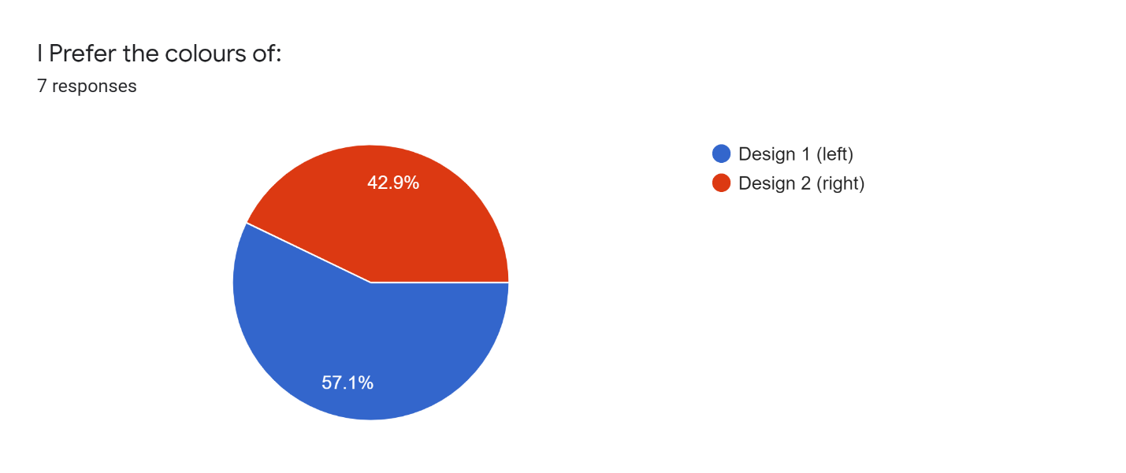

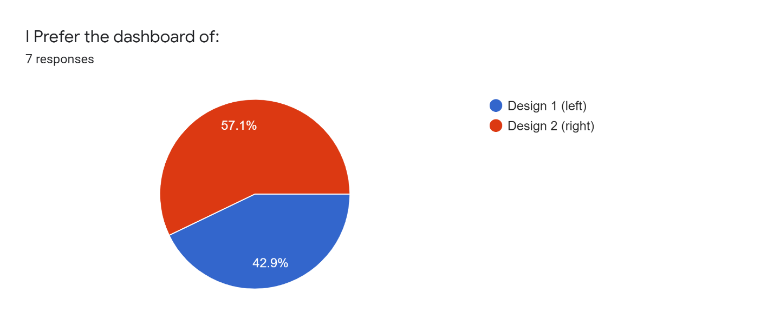

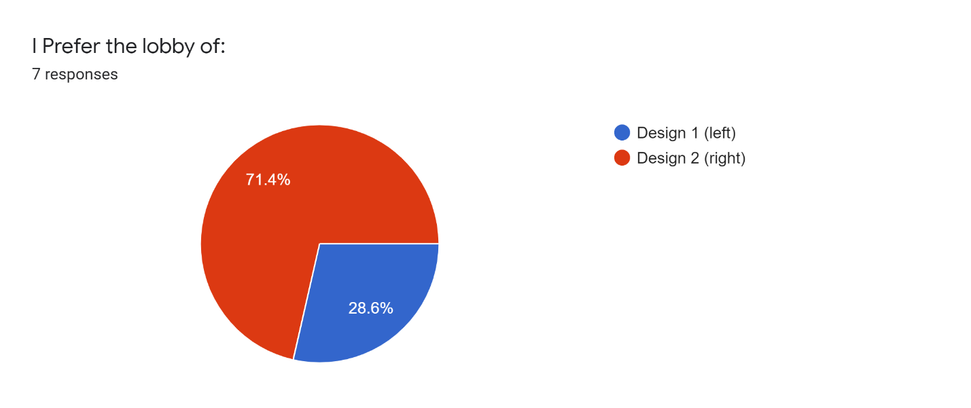

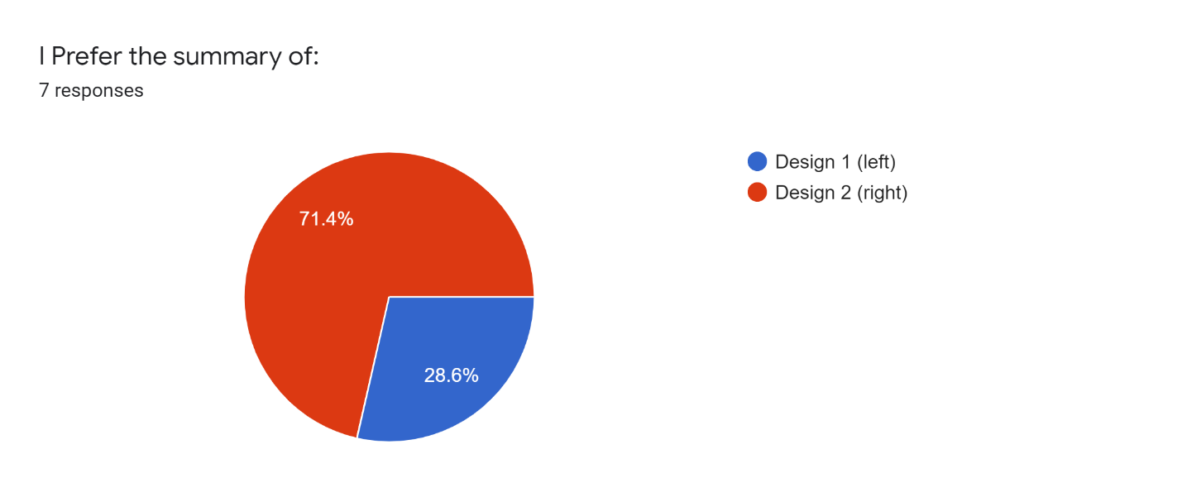

(Optional) If you went through the prototypes in the links provided, is there anything you would like to add about the two designs?

* Some of the elements from the two designs can be combined to create a better design.
* Maybe if there were wireframes with browser ads as well, they would affect my decision in the next question
* Maybe include a navigation menu (either at the top or at the side).
* not in terms of design, but could have added a game play with ads in a browser as well for demonstration

If you were a player, which game approach would you prefer to be playing, Facebook ads or browser ads?

* I would prefer Facebook ads since it is more restricted in terms of gameplay and it is more straight forward.
* browser adcs
* Browser ads so that I'm not limited to one platform
* Facebook
* Facebook because it is used daily by everyone
* facebook ads, I think it would be too confusing otherwise
* i think broswer ads for more creativity

If you had to manually input ad categories that you see while playing the game, would you still play?

* Probably not, since a page can have alot of ads. I wouldn't want to have to look for all ads in a page and then input them manually. I also believe this would ruin the transparency of the game, to the point where it feels cumbersome and boring.
* I would prefer automatic categories
* Maybe
* Yes
* If it was done in a way that was fast and efficient (for example, specifying an ad is just a simple button and we can move on)
* yes if we only specify the ad when winning, if we had to do it for every ad it would ruin the game

Is there something that is unclear about the game play?

* Ignoring technical details, the game seems pretty simple.
* No
* I didn't understand how the voting works from the high level user journey, but after looking the wireframes, it is clear
* How many players are allowed in the game
* is there a time limit? if players cant find ads what happens?

Do you have any suggestions for extra features or design decisions?

* Maybe a replay system, where players can see in depth details of games they played.
* None
* Users can play with the same members for more than one game
* Maybe players can form teams and instead of one category of ads they are given multiple
* Add a time limit

Any other comments or thoughts?

* None
* make sure players are not using ad blockers!